ADDITION AND SUBTRACTION WITH 40 DIGITS

15212017-----

MUZAFFER ARDA USLU

Eskisehir Osmangazi University

Faculty of Engineering

Departmant of Computer Engineering

Project of Introduction to Programming Lab

Lecturer Dr. Yildiray Anagun

Summary of Project

My project is a simple c program that add and subtract two numbers that are 40 digits.

What is the problem that you will deal with?

The problem, I face doing this problem is that the computer cannot store more than 16 digits as an integer, so I had to find a way to input these numbers into the computer and store them in computer’s memory and find a way to run operations on them.

What model/method/algorithm that you will apply the problem?

To solve this problem I inputted the numbers into a string and they are stored as characters. And then, I translated them into integers to carry out the arithmetic operations using a function that converts them using the ascii value 48, and add or subtract each value to its corresponding value from the second string. Add 1 to the next digit if the sum of them is more than 10 in case of addition and print sum of digits’ units digit. Subtracting 1 from the other digit and adding 10 to the number when the digit in the first string is smaller than the one in the second string in the case of subtraction.

Flowchart of addition:

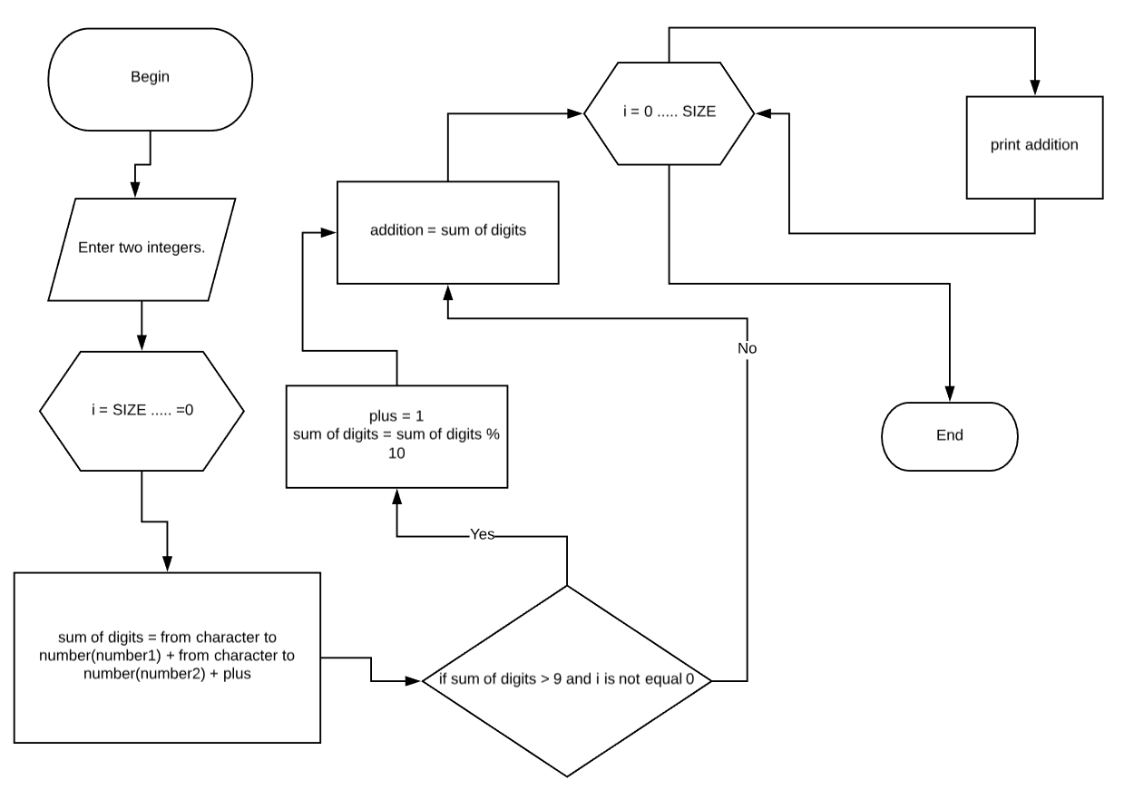

Flowchart of Subtraction: 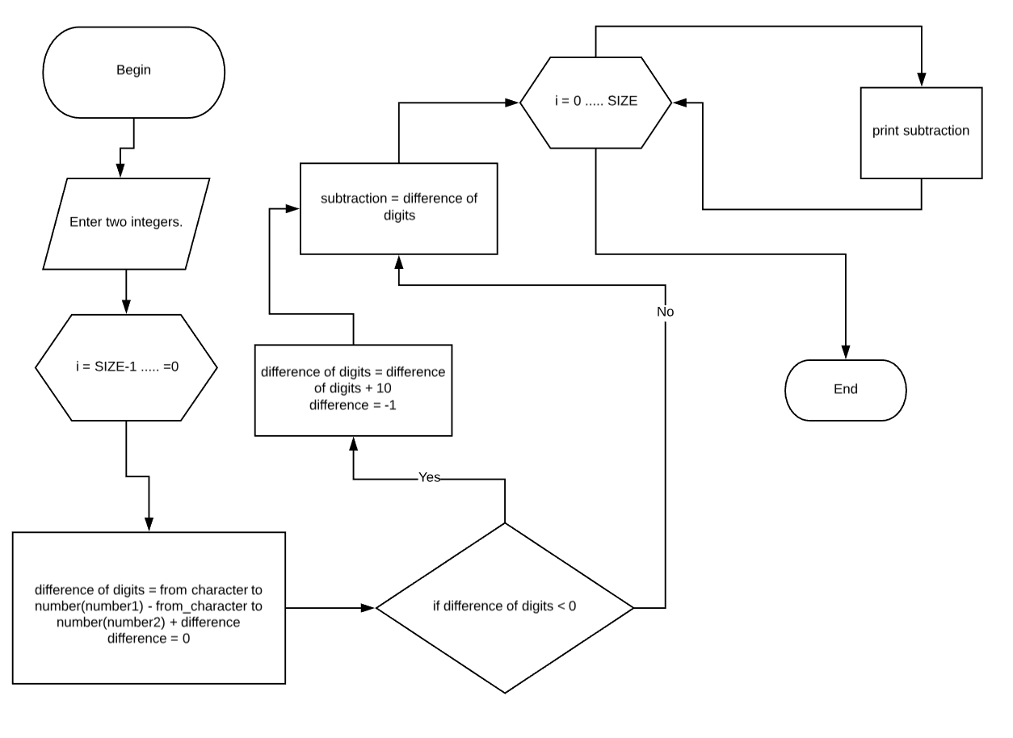

Application:

